Children’s SEF
2025 – 2026

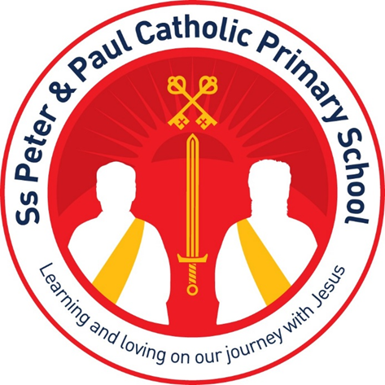

Catholic Life and Mission
How do you see our school values being lived out every day? |  | What opportunities do you have to help others and make a difference in the community?
Children help and support one another.  Pupils show kindness, compassion and respect.  Children look after others when they need help.  Pupils try to follow God's example in their actions.  Everyone is encouraged to care for one another. |  | Taking part in charity fundraising.  Supporting food bank collections and donations.  Being part of the GIFT Team.  Serving on the Eco Team and School Council.  Helping with parish and community activities.
How has being part of a Catholic school helped you grow as a person? |  | How could we make prayer, worship, and liturgy even more meaningful for children?
It has helped me to be kinder.  It teaches us to follow God.  It helps us care for other people.  It encourages us to make good choices.  It helps us show compassion and mercy. |  | Give children more opportunities to take part.  Include more activities during worship.  Make prayers easier for children to understand.  Encourage more children to lead prayers.

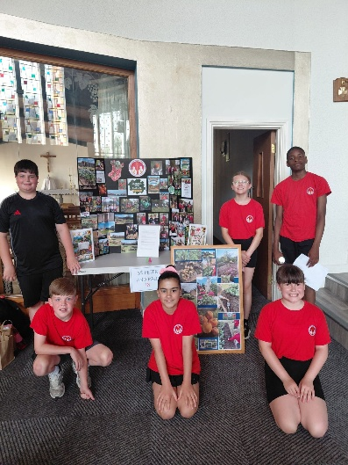
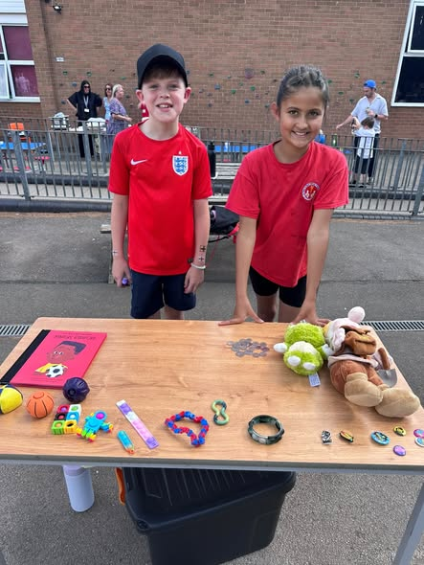
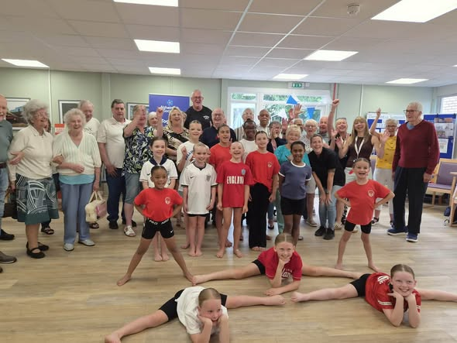

The Quality of Education
Which subjects do you feel most confident in? Why? |  | Which subjects do you find most challenging? What would help?
English because we do it every day.  Maths because teachers explain it clearly.  RE because it is enjoyable and interesting.  Art and PE because children enjoy being creative and active. |  | Some children find Maths challenging.  Some children find English and Geography difficult.  Breaking work down into smaller steps helps.  More practice and revisiting learning helps.

How well do teachers explain what you need to do to be successful? |  | What helps you remember what you have learned?
Teachers explain learning clearly.  Teachers help us when we are stuck.  Expectations are easy to understand.  Most children said teachers explain things very well. |  | Practising regularly.  Looking back in books.  Using songs and repetition.  Revisiting previous learning.
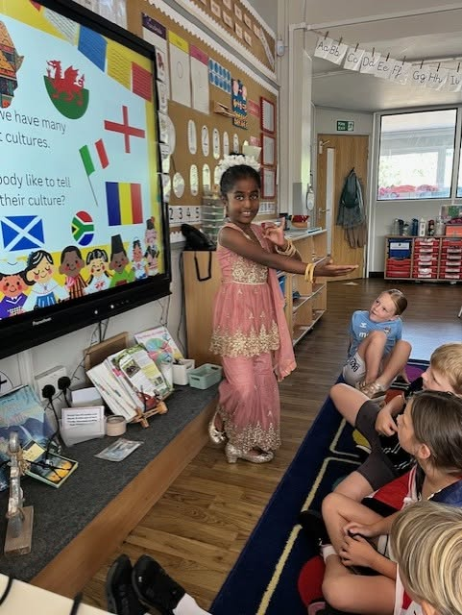
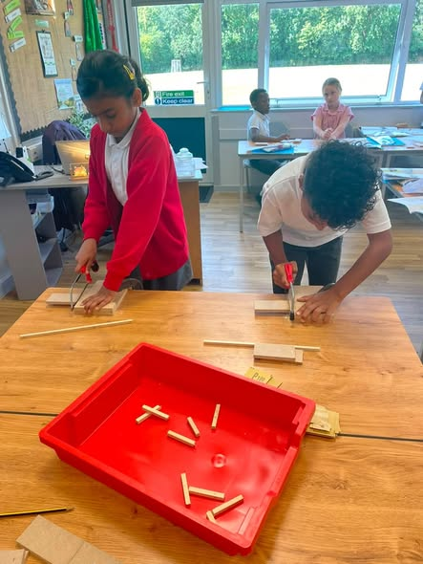
What is the best lesson or learning experience you have had this year?

Alton Castle residential.
DT projects and sewing activities.
Science investigations.
History lessons.
Culture Day.
Educational visits and trips.

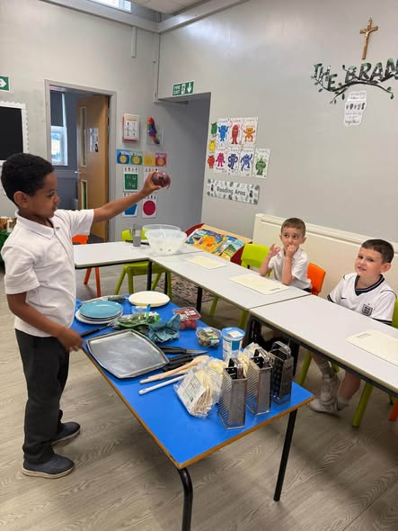

Behaviour and Attitudes
Do children behave well in lessons and around school? |  | What helps children stay focused in lessons?
Most pupils said behaviour is good.  Children behave well in lessons most of the time.  Adults help children make the right choices. |  | Listening carefully to adults.  Following classroom expectations.  Avoiding distractions.  Sitting away from friends when needed.

Do children treat one another with respect? (examples)

Children are kind to each other.

Pupils help their friends.

Children include others in games and activities.

Most pupils felt people are treated fairly and respectfully.

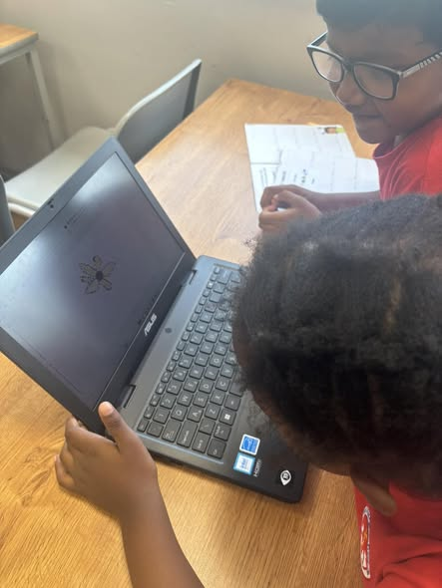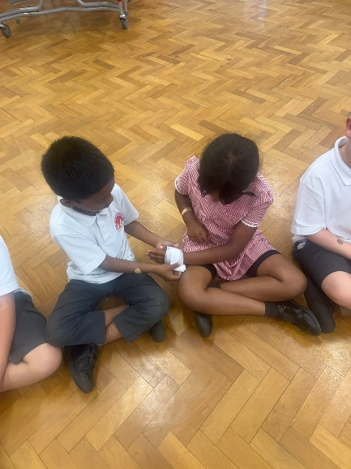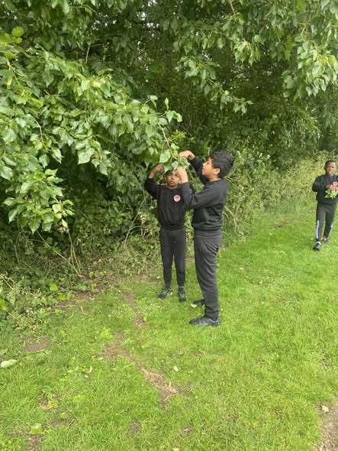

Personal Development

Who would you talk to if you were worried or upset? |  | Do you feel that everyone is included and welcomed? (how?)
Teachers.  Teaching assistants.  Mrs West.  Friends. |  | Most children said yes.  Everyone is encouraged to join in.  People are kind and welcoming.  Children said SSPP feels like one community

How well does the school help children understand and celebrate differences? |  | What opportunities do you have to be leaders in school?
Culture Day helps us learn about different cultures.  We learn about different religions.  PSHE lessons help us understand others.  Children can share their own backgrounds and experiences. |  | Head Boy and Head Girl.  School Council.  GIFT Team.  Eco Team.  Play Leaders  Buddies  Librarians
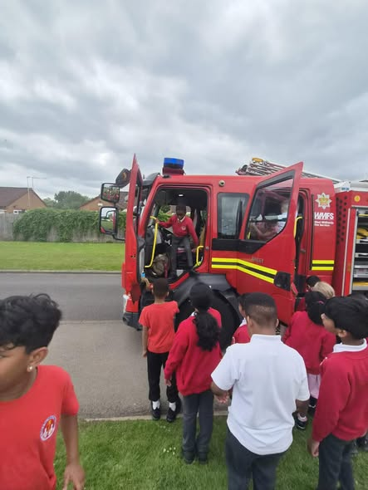
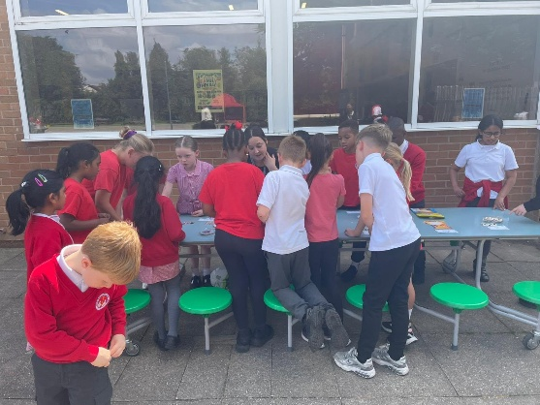
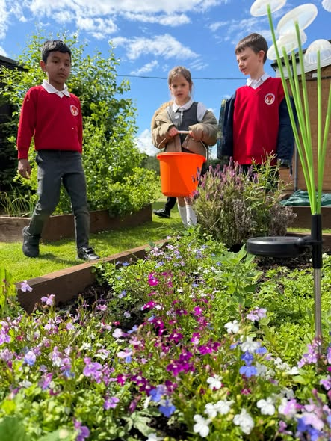

Overview
Would you recommend this school to another child? Why?
Overwhelming Yes:

The school is kind and welcoming.

Teachers care about the children.

Learning is enjoyable and interesting.

There are lots of opportunities to take part in activities and leadership roles.

Children feel safe, valued and part of a strong school community.

School Judgements
Excellent | Good | OK | Not Very Good
Learning is exciting, enjoyable and challenging. We learn a lot | We are taught well and because of this we make good progress | We enjoy school, feel safe and are given responsibility | The school is improving and getting better
100%

Information for this SEF report for Ss. Peter and Paul School was collected by members of the Y5 council. They visited each class to ask for their thoughts and opinions.

