

St John Fisher Outdoor Play
and Learning (OPAL) Policy

Responsible for policy: Claire Coyle
Date of policy: October 2025

Contents
Summary 2
1. Commitment 3
2. Rationale 3
3. Definition and Value of Play 4
4. Benefit and Risk 5
5. Supervision 5
6. The Adult’s Role in Play 6
7. Children’s Role in Play 6
8. Equality and Diversity 6
9. Environment 7
Appendix 1. Health and Safety’s Executive’s Guidance on Managing Risk in Play and Leisure 7
Appendix 2. Benefit Risk Assessment Record Sheet 7
Appendix 3. Structure of Adult Roles in Practice 8
Appendix 4. 9
Appendix 5. St John Fisher’s Children’s Play Charter 10
Appendix 6. Play Types 11
Appendix 7. Best Play – What Play Provision Should Do for Children 11

Summary
- Our setting recognises that play, especially outdoor play, is at the heart of healthy, full development for children.
- We recognise that in order to learn children must push the boundaries of what is already known and already easily accomplished and this requires children to experience risk and challenge.
- In our desire to do our best for all children in our care we are dedicated to providing a rich play setting where all children have access to stimulating environments that are free from unacceptable or unnecessary risks and thereby offer children the opportunity to explore for themselves through their freely chosen play.
- We will adopt a risk-benefit approach to manage our duty of care to protect and our duty of care to provide for children's needs.

Article 31 of the UN Convention on the Rights of the Child states that ‘A child has the right to rest and leisure, to engage in play and recreational activities appropriate to the age of the child and to participate freely in cultural life and the arts.’

‘Health and Safety Executive (HSE) fully supports the provision of play for all children in a variety of environments. HSE understands and accepts that this means children will often be exposed to play environments which, whilst well managed, carry a degree of risk and sometimes potential dangers’. (HSE, 2013)
‘Play is great for children’s wellbeing and development. When planning and providing play opportunities, the goal is not to eliminate risk, but to weigh up the risks and benefits. No child will learn about risk if they are wrapped in cotton wool.’
Managing Risk in Play Provision: An Implementation Guide (2012)

Commitment

St John Fisher Primary School recognises that play is an essential part of a happy and healthy childhood. As a school, we provide consistently high quality, sustainable play opportunities for all children. These inclusive opportunities in play are achieved by offering carefully considered outdoor spaces, equipment and toys that offer a rich choice of accessible play experiences for every child.
At St John Fisher we are committed to using our school vision and this play policy to guide our planning and actions in providing play opportunities for children. We believe play has a vital role in children’s health, happiness and wellbeing. It creates children who are independent, confident, imaginative, adaptable, social and able to assess risks.

Rationale

Children spend up to 20% or 1.4 years of their time in school at play. Therefore, this time needs to be planned for. Changes in society such as heavier traffic, busier lifestyles, improved technology, fewer areas for play and awareness of risk have led to ‘play deprivation’ for many of today’s children. This makes their play opportunities at school even more vital.
Better quality play leads to happier children and happier staff. With better quality play opportunities there are fewer behaviour problems, increased positive attitudes and stronger skills development. As the children improve their quality of play and have more enriching play times, there are fewer accidents and classroom learning is enhanced as the children come in from play, happy and ready to learn.
Play is recognised for the important contribution it makes to education and lifelong learning; a finding confirmed by many studies of early childhood. Research shows that play can enhance problem solving; it is also widely regarded as providing opportunities for social interaction and language development which is vital for all our children and in particular for EAL learners and those children with deprived speech and language. The contribution of play to educational development is suggested through the inherent value of different play types e.g. through risk taking and exploratory play in formal and informal settings, allowing children to experiment, try new things and push their boundaries in a safe environment.
We surveyed the children in January 2024 for their views on play time, they highlighted the need for improvement. Many comments were positive about their play times, but many children’s comments included; ‘there is not enough to do’, ‘I’d like to play on the field’, ‘we need more things to play with’, ‘the playground needs extra things’, ‘I want to play with children from different year groups’ and ‘it needs more resources’.

Definition and Value of Play

The Government’s Play Strategy defines play as:
‘encompassing children’s behaviour which is freely chosen, personally directed and intrinsically motivated. It is performed for no external goal or reward and is a fundamental and integral part of healthy development – not only for individual children but also for the society in which they live’.

Play meets the four components of a child’s development:
- Physical (direct impact on physical development, co-ordination and fitness);
- Intellectual (cognitive development, imagination);
- Educational (the knowledge and understanding of academic outcomes); and
- Social (the development of values, beliefs and self-perception and the parallel communication skills, leadership and teamwork this enhances).

At St John Fisher the children and staff think that:
- Play allows children to be creative and co-operative.
- Play is something you choose to do and that it is fun!
- Adults’ roles in great play is to be responsive to children’s invitations and requests, and to carry out dynamic risk assessments to weigh up the risk and benefits of play activities and develop the children’s risk awareness.
- Play may be solitary or social.
- Play invites investigation and exploration which may test boundaries.
- Play makes children happy and happy children are healthier children who in turn can learn better.
- Children have a right to play with anything/anyone they choose from the playground resources.
- Play enables children to process their experiences of the world.
- Play provides opportunities for children to develop their relationships with each other.
- Play helps promote independence, teamwork and build emotional and physical resilience.
- Through play children learn to take responsibility for their own actions.

Benefit and Risk

‘Play is great for children’s wellbeing and development. When planning and providing play opportunities, the goal is not to eliminate risk, but to weigh up the risks and benefits. No child will learn about risk if they are wrapped in cotton wool.’
Managing Risk in Play Provision: An Implementation Guide (2012)

Many research studies have found that the social, physical and mental benefits to children of managed risks are vast. Children become more resilient, adaptable and are keen to try new experiences. Children should be provided with opportunities to challenge themselves and also experience successes and failures. Risk and challenge are not limited to physical risk – it includes the uncertainties involved in making new friends, playing with children from different backgrounds and building emotional resilience through trying out new experiences with the possibility of failure.

‘Without opportunities to take acceptable levels of risk, children’s development is inhibited, undermining their capability to deal with the wider unsupervised world’. (DCFS)

At St John Fisher we are committed to providing these experiences for our children in a managed way. The Health and Safety Executive offer guidance on the provision of play in educational settings and state that:
‘HSE fully supports the provision of play for all children in a variety of environments. HSE understands and accepts that this means children will often be exposed to play environments which, whilst well managed, carry a degree of risk and sometimes potential dangers’. (HSE, 2013)

St John Fisher will use the Health and Safety Executive’s guidance on Managing Risk in Play and Leisure (www.hse.gov.uk) (Appendix 1) as its principle guiding document in making decisions relating to risk and play.

Our role as play providers is to facilitate the maximum number of enriching opportunities for children to encounter. They need to learn to manage risk for themselves in an environment that is as safe as it needs to be, rather than completely devoid of risk. The benefit to children of challenging play opportunities should be balanced with any potential risk when carrying out risk assessments. We will adopt a risk-benefit approach and will practice dynamic risk management (Appendix 2) to manage our duty of care to protect and provide for children's needs. This approach will encourage the children to identify and manage risks in an environment where adults are present to support them.

Supervision

The law requires that children in school have supervision, but for primary school playtimes there are no stated ratios. During the school day there should be one or more adult’s present outdoors. St John Fisher recognises OPAL’s three models of supervision: Direct, Remote and Ranging. Except for children in Nursery, St John Fisher does not believe direct supervision is possible or beneficial. Supervision will take remote and ranging models, so that children can quickly find an adult, and adults can patrol large areas to gain an awareness of the kinds of play and levels of risk likely to be emerging.

The Adult’s Role in Play

We, as an entire staff, are fully committed to working with children to provide the play experiences that they want and need at St John Fisher. We will have a continuing dialogue with children about the play provision in the playground which will include regular play assemblies, School Council involvement, surveys and other pupil voice outlets.
The adult’s role will also be to facilitate play and encourage children to assess the risks and benefits of activities within the play setting. The school is working with OPAL (www.outdoorplayandlearning.org.uk) to help guide a strategic approach to developing play at St John Fisher. In addition to this, the St John Fisher Play Team (Appendix 3) will work in collaboration with parents, teachers, support staff, the local governing body and all other staff as well as the children to implement the changes highlighted in this policy. Lunch time supervisors will take on the role of the Play Team. They will ensure that the broadest possible range of play opportunities are available to children: to observe, reflect and analyse the play that is happening and select a mode of intervention or make a change to the play space if needed. The Play Team will be guided by OPAL and the Play Principles (Appendix 4) to ensure that the play space is inclusive – supporting all children to make the most of the opportunities available in their own way. Playworkers are a channel of access to new materials and tools and they can act as a stimulus to children to explore and learn. They are also available to participate in the play if invited.

Children’s Role in Play

The children will all have access to their own version of the play policy (Appendix 5). In it will also include the rights and responsibilities of the children to:
- Have ownership of their play and outdoor learning experiences.
- Respect and look after each other their environment and equipment.
- To take responsibility of their actions surrounding purposely dangerous or unsafe behaviour.
- Ensure that playtimes are fun for everybody.

This children’s charter will be shared and explained to all children regularly as part of ongoing assemblies, discussions and dialogue in class and with the School Council.

Equality and Diversity

Through providing a rich play offer meeting every child’s needs we will ensure all children, (regardless of age, gender, race, disability or other special needs,) can develop and thrive, build strong relationships and enjoy school.

Environment

We believe that a rich play setting should ensure that all children have access to stimulating environments that are free from unacceptable or unnecessary risks and thereby offer children the opportunity to explore for themselves through their freely chosen play.
We will strive to continually improve the quality and diversity of our school’s grounds to enhance play.
At St John Fisher we will:
- Use the outdoor space as a natural resource for learning and playing, encouraging the children to value natural or found objects for play.
- Include the children when planning for playing and learning outdoors.
- Ensure that the outdoor area offers all children the opportunity to investigate, take risks, explore and use their imagination and creativity.
- Expect the children to respect the outdoor environment and care for living things.
- Give children the opportunity to manage the space and freedom afforded by the outdoors.
- Enrich the quality of the environment to maximise the variety of play types (Appendix 6) and increase play value.
- Ensure that the play space is an integrated area where all children from reception to Year 6 can play safely.
- Teach the children their responsibilities with regard to maintaining the quality of their outdoor space, and the equipment available and ensure they take an active part in doing this.
- Promote children's love, pride and enjoyment of the outdoors, a key foundation for caring for the environment.
- Help children develop confidence in team building and advocating their own rights.

We will use the document ‘Best Play’ to guide us on what a quality play environment should contain (Appendix 7).

Appendix 1. Health and Safety’s Executive’s Guidance on Managing Risk in Play and Leisure

CHILDREN’S PLAY AND LEISURE – PROMOTING A BALANCED APPROACH

See PDF attached

Appendix 2. Benefit Risk Assessment Record Sheet

Benefit-Risk Assessment Record Sheet

Risk Assessment Date…………… Assessed by…………

 | Description of Activity, Principle or Object, who might be at risk and what kind of harm. | Benefit or Utility  Or Related Policy | Description of risk management and maintenance agreed | Nominated person | Action Date

Appendix 3. Structure of Adult Roles in Practice

OPAL Team

Executive Principal – Mr Madia
Play Co-ordinator – Mrs Coyle
Play Leader – Miss Ryan
Parent/Staff Representative – Kelly Smith
Parent Representative/ Associate Governor – Sharon Boyle
Site service officer – Paul Murry and MAC site services team.

St John Fisher Play Team

All adults working at the school are part of the play team and have a responsibility to follow this policy. When on the playground at playtimes all staff should act as Play Makers.

However, more specifically at lunch times the following structure exists:

Play Co-ordinator
(Leads and manages strategy) Marie Ryan

Play Leader
(Leads and manages playtimes) Claire Coyle

Assistant Play Leader
(Supports play leader and steps up in their absence) George Lingley

Play Makers
(Support children’s’ play as described in section 7

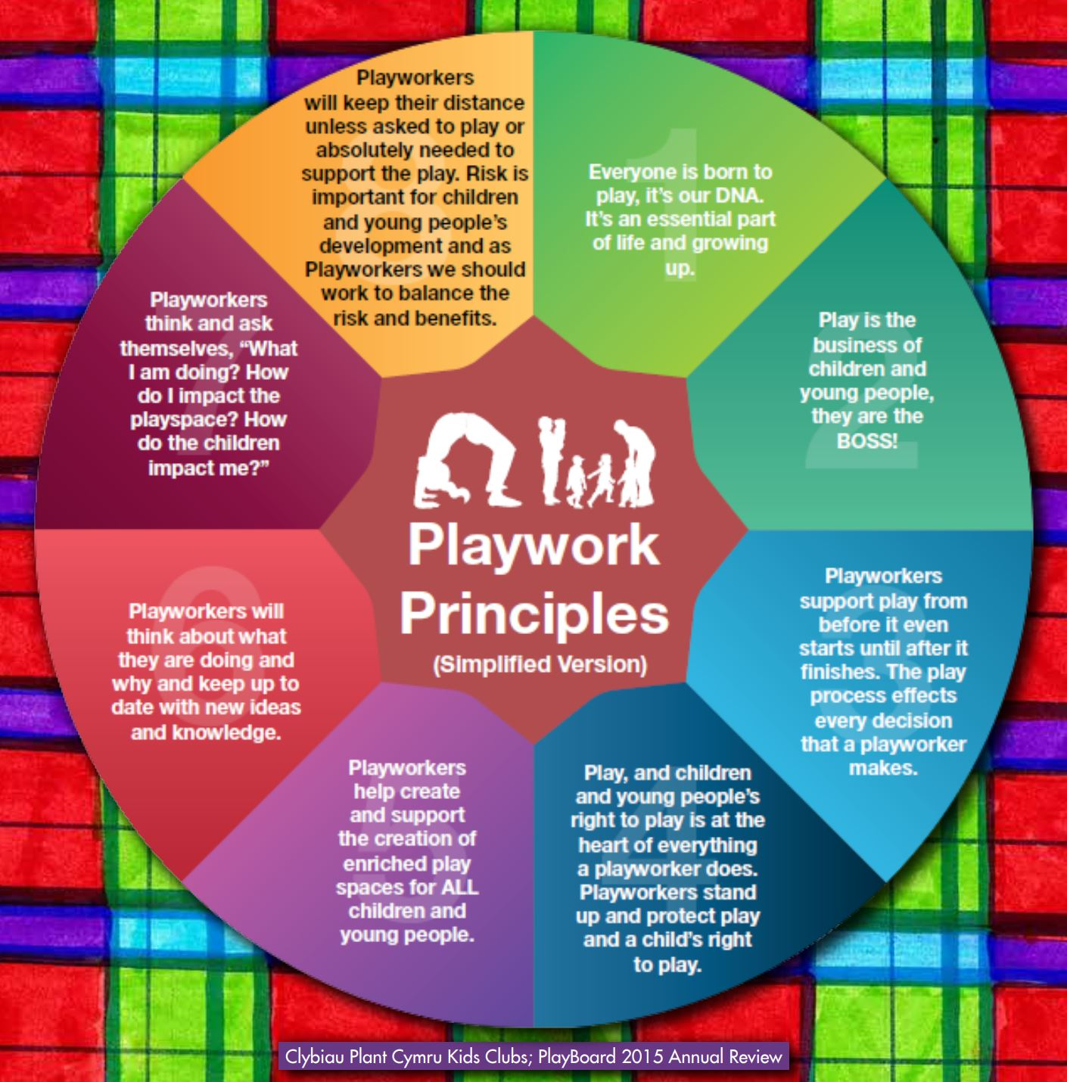
Appendix 4.

Appendix 5. St John Fisher’s Children’s Play Charter

St John Fisher
Children’s Play Charter

We have the right to play and enjoy Outdoor Play And Learning (OPAL)

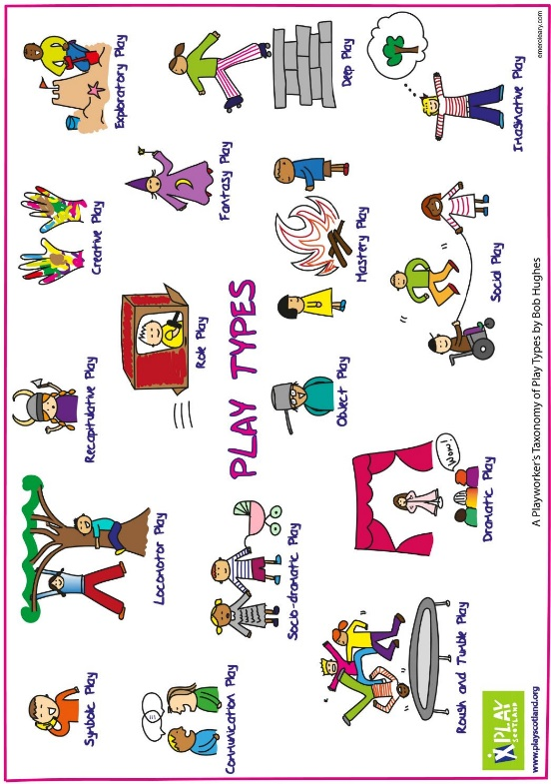
At St John Fisher, we all agree to follow these rules.
We will make sure everyone enjoys playtime by making sure:
- We share and tidy equipment away
- Invite people into your games to include everyone
- Treat the equipment with respect
- Respect all children, staff and vistors
- Act safely
- Be kind

- Signed:

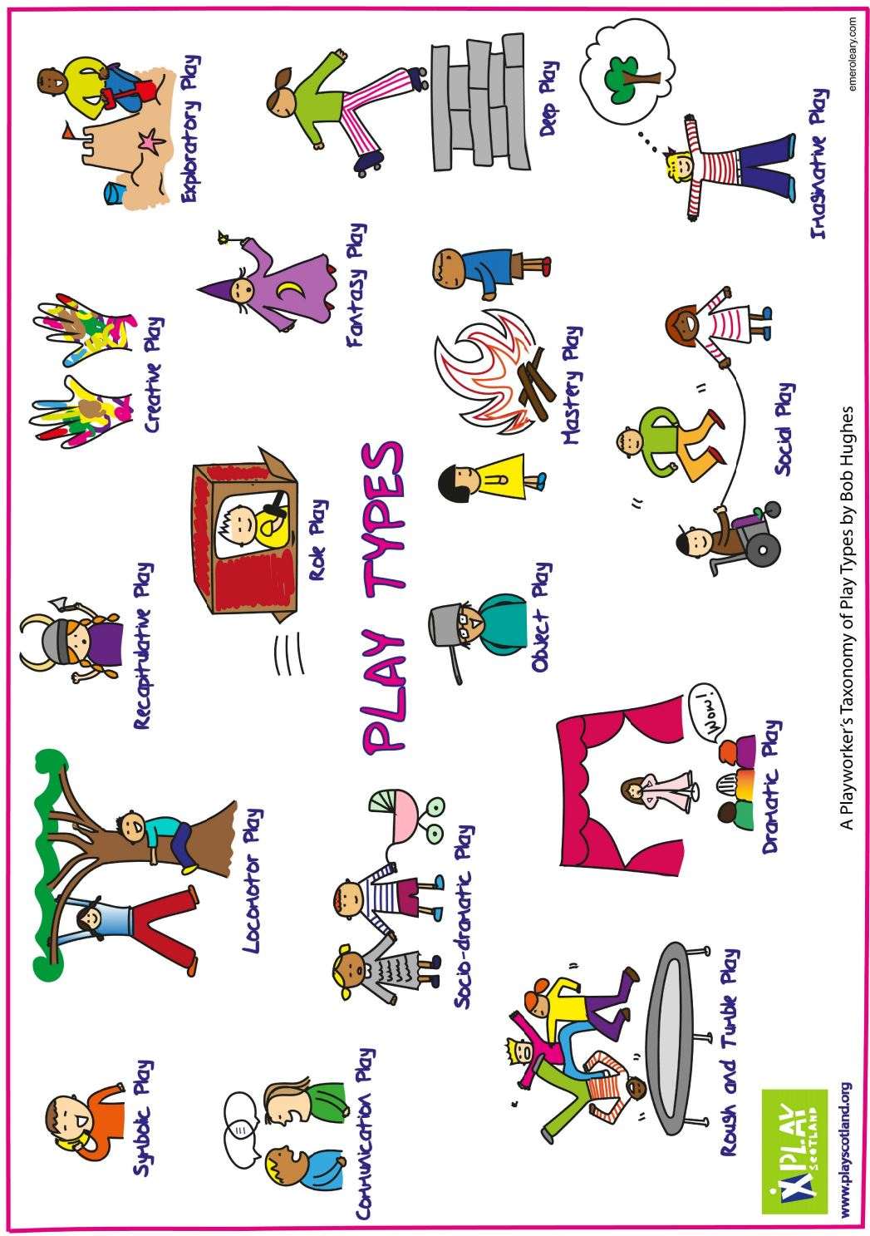
Appendix 6. Play Types

Appendix 7. Best Play – What Play Provision Should Do for Children

BEST PLAY – WHAT PLAY PROVISION SHOULD DO FOR CHILDREN

See SharePoint Link:
Appendix 7 - Best Play -What Play Provision Should do for Children.pdf

