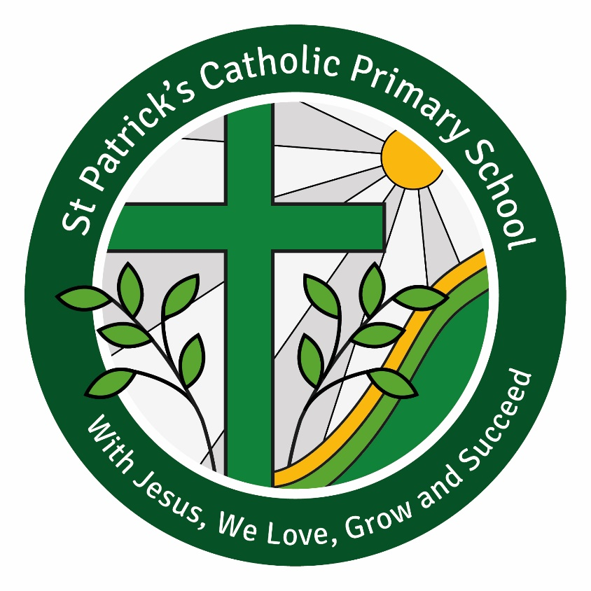

Handwriting Policy

Written November 2025
Review September 2026

Handwriting Policy
Handwriting and Presentation at St. Patrick’s Primary School
At St. Patrick’s Primary School, we believe that neat, well-formed handwriting and good presentation help pupils take pride in their work and support their learning.

Purpose
Handwriting, like reading and spelling, is an important skill that affects written work in all subjects. With good teaching and regular practice, most pupils can develop fluent, legible, and joined handwriting as they progress through the stages of our handwriting programme. Neat and well-formed handwriting supports children’s learning and helps them take pride in their work.

Aims
- To improve writing across the school by following a clear and structured handwriting programme divided into progressive stages.
- To set high expectations for handwriting and presentation.
- To ensure all staff follow the same approach when writing in children’s books, on whiteboards, and for displays and resources.

For Teachers
- To have a thorough understanding of the correct handwriting style, including letter formations, joins, and progression through the stages.
- To deliver handwriting lessons using the agreed routines and resources.
- To maintain high expectations during handwriting lessons and ensure pupils consistently apply the same standards in their independent writing.

For Pupils
- To recognise the value of clear and neat presentation as a means of effective communication.
- To develop legible handwriting with increasing fluency and speed.
- To hold a pencil correctly, form letters accurately, and apply correct size, spacing, and placement of letters.

Handwriting Stage 1
We start teaching separate handwriting lessons as soon as children can read Set 1 sounds. We now teach letters in handwriting families. Each family has a common formation:
a d g o c q
u y
b p
h n m r
e s f i
l t k j
v w x z
Children continue to write on plain paper.
Stage 1 Lesson Plans – Blueprint Routine:
1. Use MTYT (My Turn, Your Turn) to say the handwriting phrase: “Round the apple, down the leaf.”
2. TOL (Think Out Loud) as you use the checklist to write the letter on the board:
✓ start at the stalk
✓ go round the apple
✓ go back up to the stalk, then down
✓ curl the leaf at the bottom.

Handwriting Stage 2
Letter Village films are available on the Ruth Miskin Training School Portal, starting from Stage 2. They teach children, step-by-step, how to develop joined handwriting in just ten minutes each day. At Stage 2, we teach a mature handwriting style that will flow easily into joined writing. Start using the Letter Village films when the children in your Year 1 class can write with correct basic formation. Children in Year 2 and above will also benefit from following these lessons before they begin learning to join letters.
We introduce new ‘picture hooks’ to help children ‘visualise to memorise’ the shape of letters. This is important. We do not ask children to copy – copying means they haven’t memorised and may form letters incorrectly. In Reception, children connect the letters they read with the shape they write. By Year 1, children should be confident to read and write the letters with the correct formation.

At Stage 2, letters are grouped by similar formation:
a d g o c q
u y
b p
h n m r
e s f i
l t k j
v w x z

Handwriting Stage 3
Children return to Letter Village for Stage 3. They will learn two joins: the ‘hill’ join and the ‘bridge’ join. There are three variations of both joins:
- Hill to jam letter
- Hill to top sponge letter
- Hill to ‘sister’ letter
- Bridge to jam letter
- Bridge to top sponge letter
- Bridge to ‘sister’ letter.
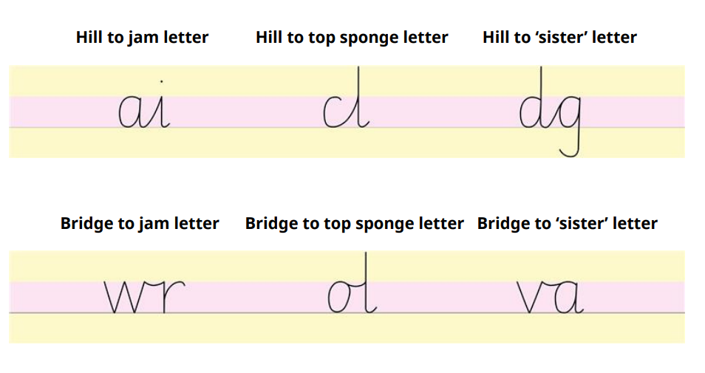
Children practise each join with specific letter combinations, then write words with the joins they have practised. We teach children that all letters are joined with the ‘hill’ or ‘bridge’ join, except for g, j, q, y and z. We modify some letters (e.g. r, e, s) to allow them to join.
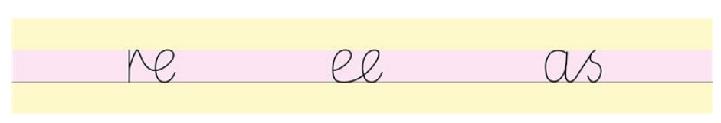

Sponge Cake Layers:
We use an imaginary sponge cake so children can visualise where to place each letter on the line: jam in the middle, sponge on the top and bottom. Children watch the ‘How to use the sponge cake’ film on the Ruth Miskin Training School Portal. Remind children of the layers at the start of each lesson. Some schools may use handwriting tram lines to support this.
Children will learn a fully joined style that is legible, fluent, and consistent. Photographic examples of correct joins and sponge cake placement should be displayed and modelled during lessons.
Children will learn a style that looks like this:
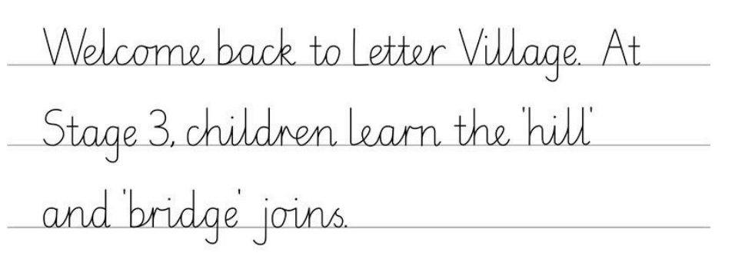

Presentation Expectations
- Write the date and title neatly.
- Use correct spacing between words.
- Words should sit on the line with ascenders and descenders placed accurately.
- Rub out mistakes carefully or draw one neat line through the error.

Pencils and Pens
In the early stages, pupils begin writing with HB pencils. In Stage 2 and Stage 3, pupils may progress to using pens once they demonstrate neat, consistent handwriting. A ‘Pen Licence’ may be awarded as recognition of this achievement. Once achieved, they can use a pen for writing across all subjects, except for Maths, where pencil use continues for accuracy and ease of correction.

